**The Risky Business of Safe Investing: Optimizing Conservative Portfolios**

Ian Lucas and Carrie Little

Shiley-Marcos School of Engineering, University of San Diego

AAI500: Probability and Statistics for Artificial Intelligence

Leonid Shpaner, M.S.

AAI-500-02: Final Project Group 9

October 21, 2024

**The Risky Business of Safe Investing: Optimizing Conservative Portfolios**

**Introduction**

Due to a stagnant economy coupled with rising interest rates in the year 2022, bonds and stocks experienced a dramatic increase in their correlation while falling in value simultaneously. This led to a breakdown in diversification and significant losses in ostensibly conservative portfolios. Figure 1 shows this for the supposedly safe Vanguard LifeStrategy Income Fund (VASIX), which consists of 80% global bonds and 20% global stocks. VASIX experienced a 17% drawdown and still has not recovered its value from three years ago. Figure 2 depicts the correlation between stocks and bonds, as represented by the rolling 12-month correlation between the Vanguard Total World Stock ETF (VT) and PIMCO 25+ Year Zero Coupon US Trs ETF (ZROZ). The correlation started 2022 near zero, but rose above 0.50 over the course of the year and has remained high ever since. While the nearly 10-year correlation between the two is a low 0.11, the instability in this relationship revealed a vulnerability that became manifest in 2022.

*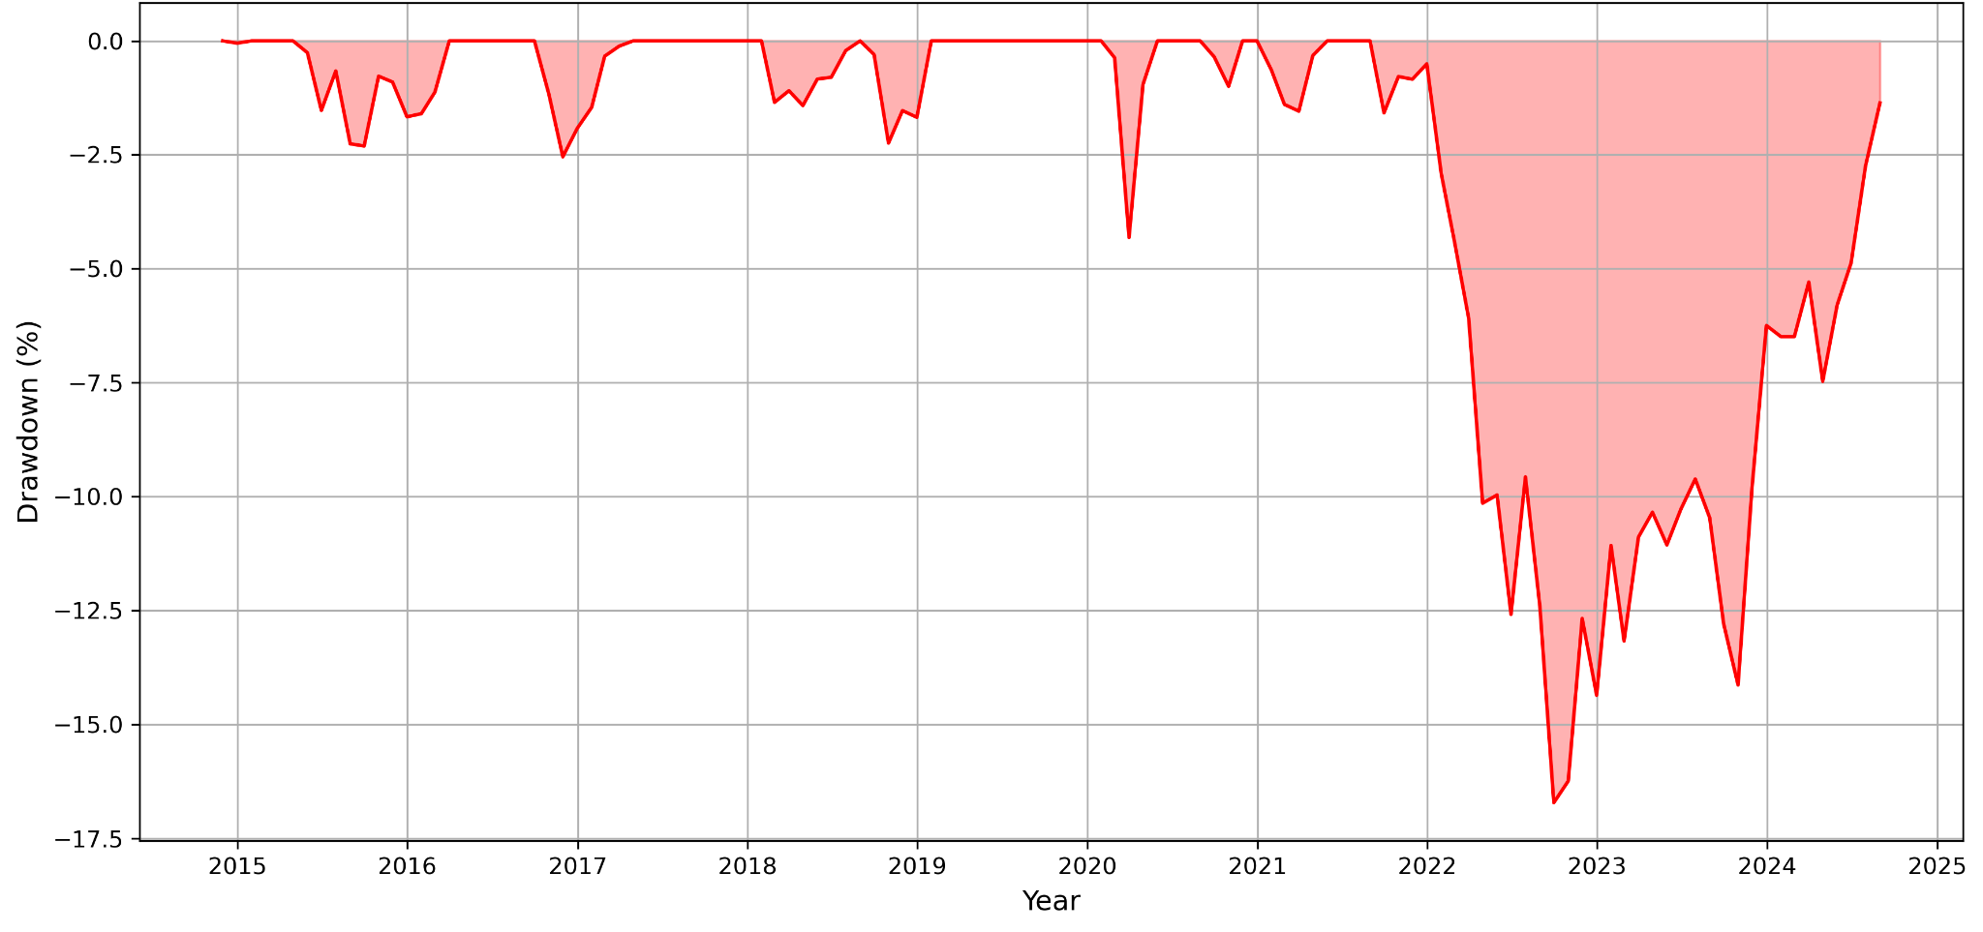Figure 1 - Drawdown Analysis for VASIX*

*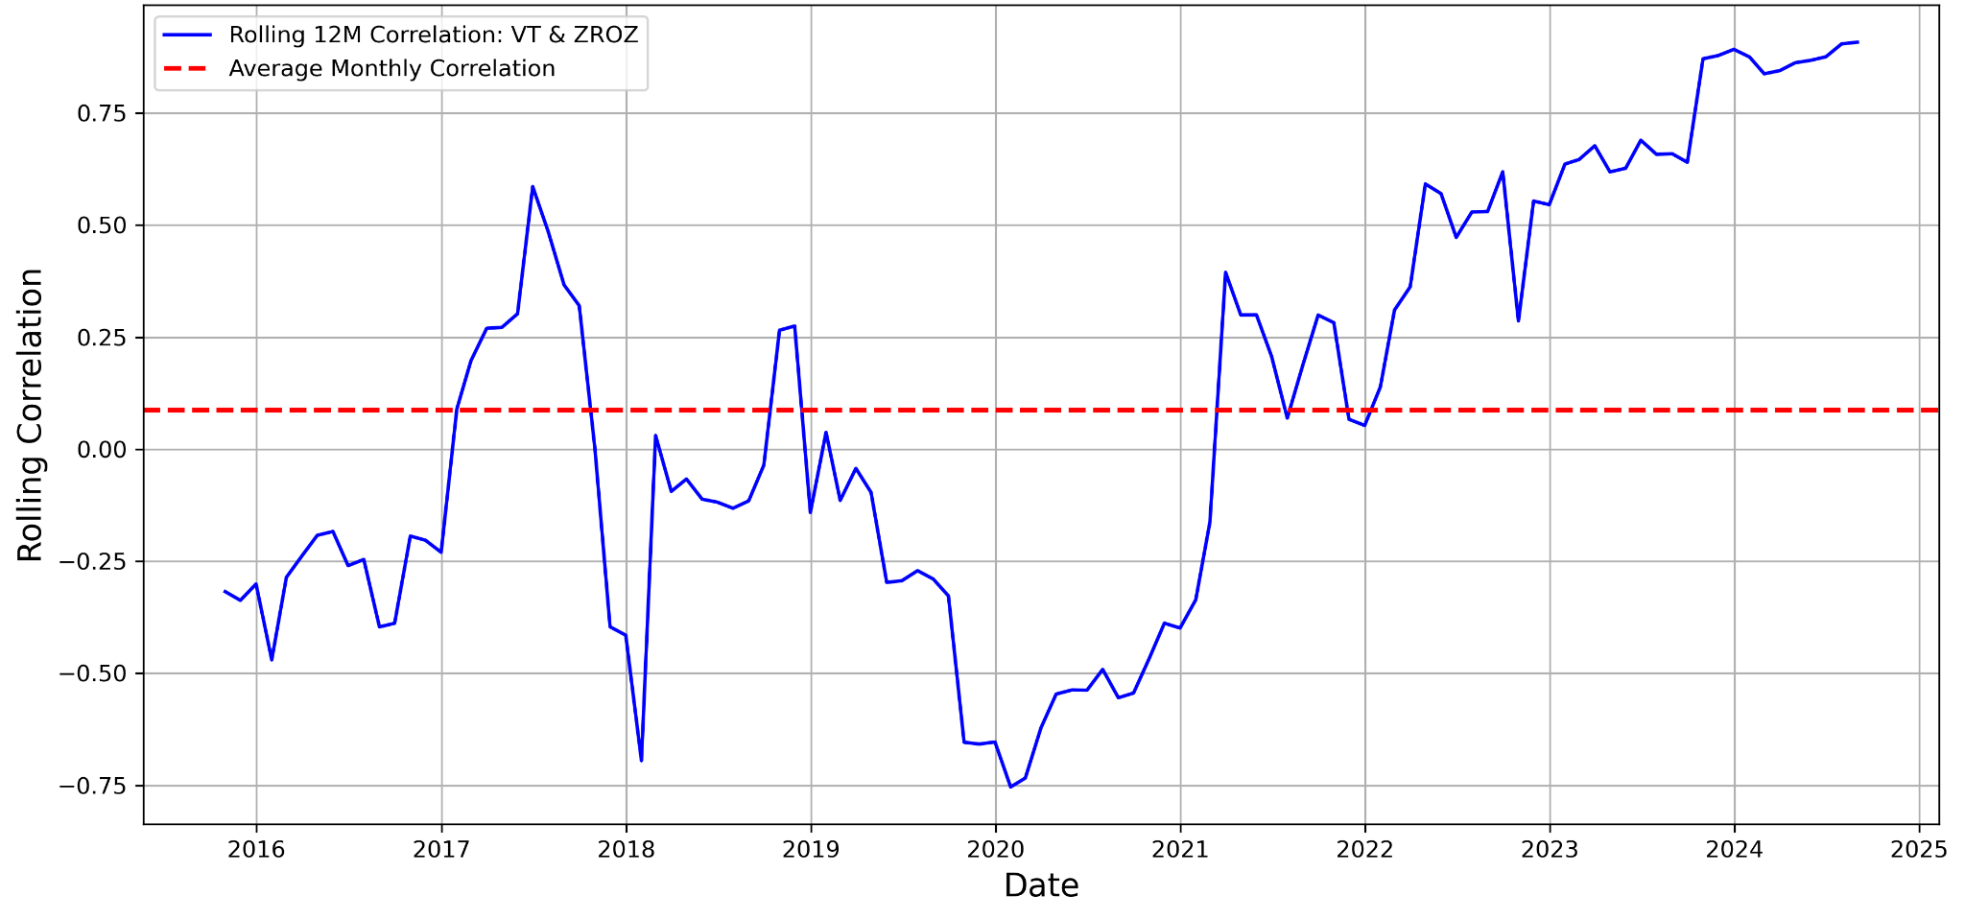Figure 2 - Rolling 12-month Correlation Between Stocks and Bonds*

In response to significant losses experienced by our clients in 2022 within their conservative asset allocation strategies, our asset management firm seeks to explore more robust portfolio strategies. Many clients shifted their investments to Treasury Bills when interest rates surpassed 4.0%, finding solace in these seemingly safer options. However, with the Federal Reserve beginning to lower interest rates, clients are looking for new strategies that offer total returns of 4.0% or more without the substantial drawdowns they encountered in 2022.

In this report, we investigate a variety of liquid investments across a spectrum of correlation profiles. By combining these diverse assets, we can meet the needs of our clients, offering better risk-adjusted returns. We employ portfolio optimization techniques to evaluate Risk Parity, Minimum Variance, and Maximum Diversification approaches. Our analysis concludes that a Risk Parity allocation offers the most balanced risk-return profile, avoiding the exclusion of any particular asset class, and better aligning with the evolving needs of our clients.

**Data Cleaning/Preparation**

For this analysis, we gathered monthly total return data for 15 mutual funds and exchange-traded funds (ETFs) from Portfolio Visualizer. The dataset covers the period from November 2014 through August 2024–the longest common time period in which all the funds were available. There are 118 months of data for each asset. Vanguard LifeStrategy Income Fund (VASIX) serves as the benchmark for this study and the other 14 assets represent our opportunity set.

The dataset was formatted with monthly returns in decimal form, with no missing data points. Because the data came from a single source in a standardized format, minimal preparation was required. However, in a different research context, we might have needed to handle missing data points, different data types, multiple data formats, currency conversions, and inconsistent timeframes. Additionally, we might have considered data smoothing techniques to account for outliers, particularly in highly volatile assets like Bitcoin. For our present analysis, we used the raw data to reflect real-world outcomes for publicly available investment products, but later will discuss extending the analysis with additional data of varying types. Future analysis may also warrant data transformations in order to satisfy the assumptions of various statistical models.

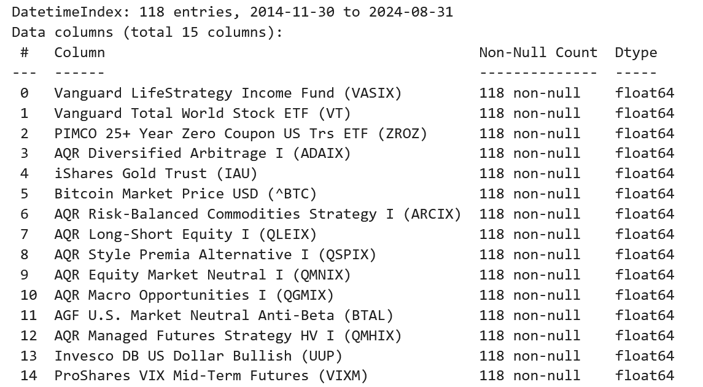

*Table 1 - Dataset Info*

**Exploratory Data Analysis**

Our exploratory data analysis evaluates each asset's potential role in diversification. Later, we will put this to the test with a variety of optimization methods that aim to reduce overall portfolio risk below that of the benchmark while preserving a satisfactory return profile through shifting economic environments. First, however, we need to deepen our understanding of the statistical properties of each asset.

***Correlations***

Because our focus is on diversification, we begin with an examination of the correlation matrix, which tells us a high level story about the relationships between all of the assets. We are most interested in understanding two things with regards to the correlations.

First, we want to know how correlated each asset is with respect to the benchmark, VASIX. To the extent that the assets provide a diversification benefit, they will need to have a relatively low correlation to VASIX. This is important because, while stocks and bonds have a near-zero correlation to one another over time, that correlation is not static, as we saw earlier in Figure 2. Our hope is that a number of the assets exhibit low and possibly even negative correlations with VASIX (and, by extension, with stocks and bonds). If they do, then it hints at the potential to mitigate extreme negative events like those experienced in 2022.

Second, we want to understand the cross-correlations among the assets. Ideally, they have low correlation with one another that is stable over time. This is critical for the reason that we examined at the start of this paper. Namely, although stocks and bonds exhibited a low overall correlation, their relationship was not stable, leading to a breakdown in diversification and steep losses.

To those ends, the correlation matrix in Figure 3 helps us visualize the potential diversity available to us in our opportunity set (note that we are only displaying the lower triangle of the correlation matrix). We make a number of initial observations.

* On average, the 14 assets have a 0.03 correlation with VASIX. This suggests that they may provide meaningful diversification from a conventional conservative allocation such as that provided by VASIX.
* VASIX and the Vanguard Total World Stock ETF (VT) have high positive correlation (0.80), which makes sense because the global stock allocation of VT is a part of VASIX.
* The PIMCO 25+ Year Zero Coupon US Trs ETF (ZROZ) also has a relatively high correlation with VASIX of 0.62, which also makes sense because the global bond component of VASIX is sensitive to changes in interest rates, to which ZROZ is especially sensitive.
* Promisingly, the next highest correlation with VASIX comes from AQR Diversified Arbitrage I (ADAIX) fund and iShares Gold Trust (IAU), coming in at a modest 0.39 and 0.37, respectively.
* From there, the correlations with VASIX drop off quickly, with seven assets demonstrating a negative correlation as low as -0.51 for the Invesco DB US Dollar Bullish (UUP) fund.

Here are some highlights regarding cross-correlations among the assets in the opportunity set (not including VASIX):

* The average cross-correlation of the 14 assets (excluding the correlation of each asset with itself) also is 0.03, indicating that they will work well with one another.
* Three of the 14 have a high correlation above 0.70 with one another–AQR Long-Short Equity I (QLEIX), AQR Equity Market Neutral I (QMNIX), and AQR Style Premia Alternative I (QSPIX).
* There are two other instances of cross-correlations slightly above 0.50–the AQR Managed Futures Strategy HV (QMHIX) fund has a 0.56 correlation with the AQR Global Macro Opportunities (QGMIX) while ADAIX has a 0.51 correlation with VT.
* Numerous assets have negative correlations with one another. For example, ProShares VIX Mid-Term Futures (VIXM), AGF. U.S. Market Neutral Anti-Beta (BTAL), and UUP all have correlations below -0.50 with global stocks (VT).

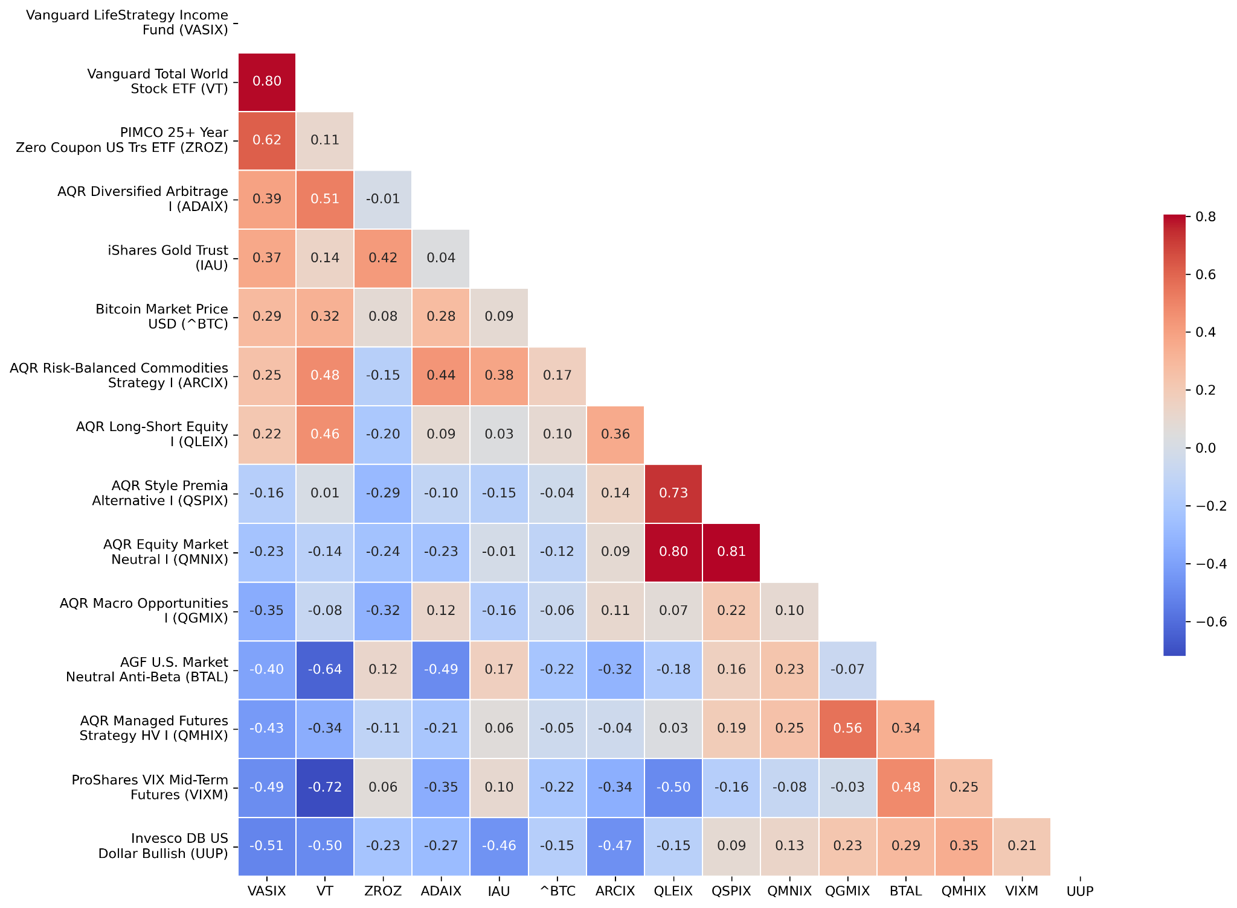

*Figure 3 - Correlation Matrix Heatmap (Lower Triangle)*

Looking under the hood, Figure 4, on the next page, shows that the average cross-correlation was low throughout the period studied. The highest it ever reached was a mere 0.12 in late 2017. In 2022, it oscillated around 0.00, indicating that diversification was maintained during this critical time frame.

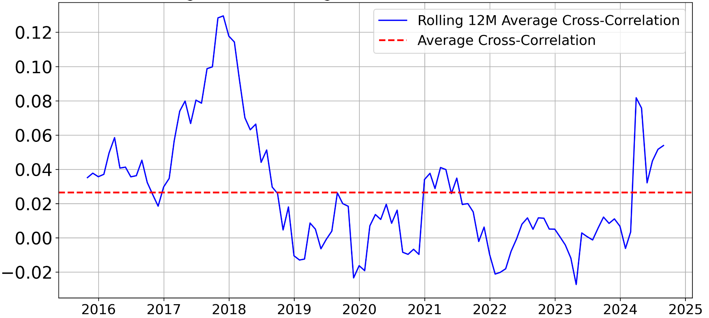*Figure 4 - Rolling 12-month Average Asset Cross-Correlation (excluding VASIX)*

***Monthly Risk and Return Summary***

From correlations, our exploration moves on to consider the basic return characteristics in the assets. Turning our attention to Table 2, which is sorted in descending order of each asset’s correlation with the benchmark, we make a number of initial observations related to risk and reward. We will start by considering the risk characteristics of the monthly returns as represented by standard deviation, minimum 1-month return, and skew. Then we will consider the reward side of the coin in terms of the arithmetic average (mean) monthly return.

VASIX has a lower monthly standard deviation (1.63%) than every other asset, indicating that it is a relatively conservative investment. Similarly, its lowest 1-month return (-4.92%), while steep, was less severe than 13 of the 14 assets–only UUP had a slightly less bad worst month (-4.73%). In fact, six of the assets had minimum 1-month returns below -10.00%. The higher volatility and worse minimum returns tells us that the assets are individually quite risky. The seemingly favorable correlations noted above will be put to the test if the goal is to achieve a better risk profile than VASIX.

Interestingly, the skew of VASIX was -0.24, which is worse than all but two of the other assets. This indicates the presence of sharp losses for VASIX relative to its full distribution of returns, which we already know were experienced in 2022 and will explore in more detail later in our analysis. The fact that 11 of the 14 other assets had positive skew provides some hope that, when combined, they may truncate the left tail and mitigate severe losses. But it is too early to get our hopes up because it is not yet clear if their steeper individual losses and higher volatility can be diversified away. That the maximum monthly return for 10 of the 14 assets exceeded 10.00%, coupled with the fact that the mean return was above the median for 11 of the 14 assets, is indicative of the positive skew exhibited by many of them.

The mean monthly return for 11 of the 14 assets is equal to or greater than VASIX’s 0.29% monthly return (with BTC being notable for its extreme monthly return of 6.67%). Only one, VIXM, had a negative mean, suggesting that its strong diversification potential (stemming from its -0.49 correlation with VASIX) may come at the cost of a lower return. However, the fact that most assets have a higher mean return suggests the possibility that they could offer a reasonable return relative to VASIX while pursuing diversification.

One interesting observation is that the mean return tends to be quite small compared to the standard deviation. This is important because investors care about *compounded* (geometric) returns, which are always lower than arithmetic mean returns in the presence of positive variance. Consider an extreme example to illustrate the point. Suppose and investment rose 50%, increasing a $10,000 starting value to $15,000. Then, in the second period, it fell by 50%, cutting the value down to $7,500. The arithmetic mean (+50%, -50%) is zero, but the compounded growth rate is negative. Because VASIX has a low standard deviation, it suggests that it may suffer from less of a return drag due to volatility than the other assets. We will see later that this phenomenon results in VASIX having a larger compounded return than six of the other assets owing to its low standard deviation, whereas in arithmetic mean terms, it only surpasses one other asset.

One quick note is that the positive kurtosis seen in most assets, coupled with their skew, is a sign that their returns are not normally distributed, which we will explore in more depth below.

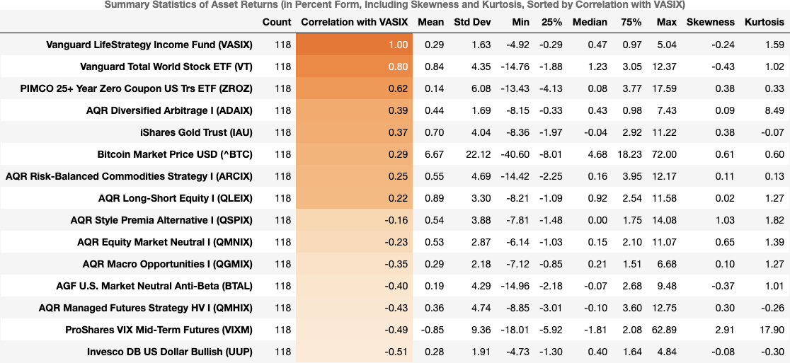

*Table 2 - Asset Summary Statistics*

***Monthly Return Time Series Plots***

Figure 5 plots the monthly return time series of each asset over the nearly 10-year period. The main takeaway from this is that returns vary wildly from month to month, which is in keeping with the standard deviations being so high relative to the mean, as we saw in Table 2. Sometimes assets can go years with relatively “quiet” returns that belie their embedded risks before sudden spikes in volatility bring those risks to the forefront–VASIX, ADAIX, and QSPIX are good examples of this, though all of them how this property to some extent.

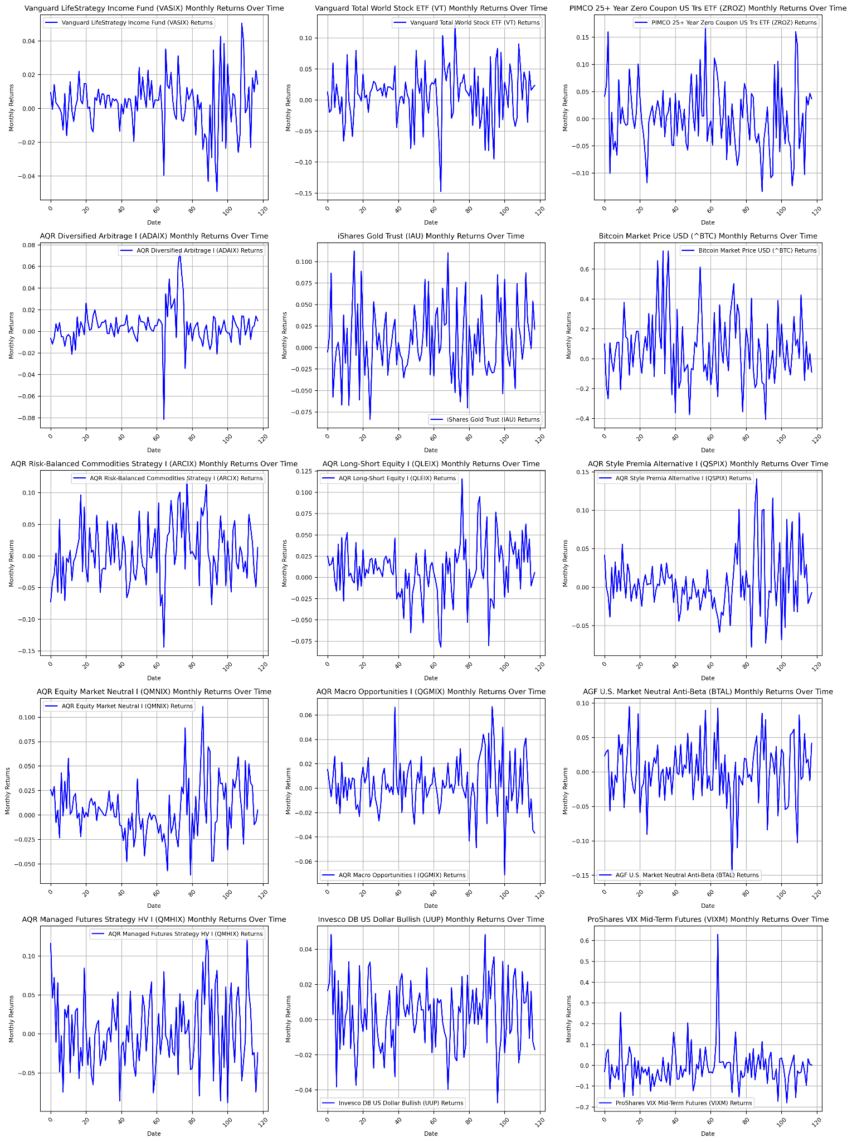

*Figure 5 - Monthly Return Time Series*

***Box-Whisker Plots***

The box-and-whisker plots in Figure 6 provide additional context on each asset's variability and distribution of returns. Numerous assets exhibit narrow interquartile ranges (IQRs) and short whiskers (e.g. ADAIX, QGMIX, UUP), indicating stable return profiles. Others that show wider IQRs consistent with their higher volatility (e.g. ZROZ, ARCIX, QMHIX, VIXM, and especially BTC).

Multiple assets with narrower IQRs still exhibit outlier returns (VASIX, in particular), so we will need to dig into outliers later because extreme events can significantly impact overall portfolio performance, and proper diversification and risk management are crucial for mitigating such risks. 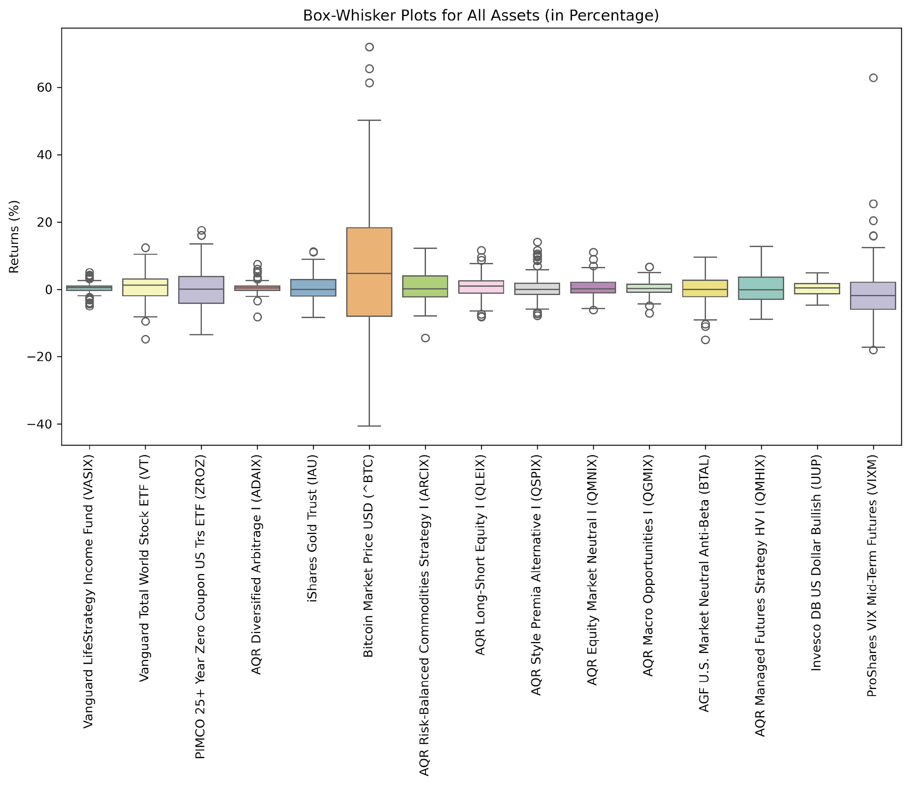

*Figure 6 - Box-Whisker Plots*

***Outlier Analysis***

Table 3 examines monthly return outliers for the benchmark asset, VASIX. It is sorted from the most positive to the most negative outlier. We see that VASIX experienced seven positive outlier months and eight negative outlier months, with five of the eight negative outliers occurring in 2022 alone. The purpose of this analysis is to see if diversification was preserved when it mattered most. To see that more clearly, you can turn your attention to the bottom of Table 3, which shows the average negative outlier return for VASIX was -3.21%. We observe that seven of the assets averaged a negative return when VASIX had a negative outlier, with three of them (VT, ZROZ, and BTC) generating a worse loss than the benchmark. However, seven other assets actually produced a positive return when VASIX was in a negative outlier condition, with the least positive among them being +2.49%. Overall, these seven assets maintained a negative correlation with VASIX when it was in an outlier condition (both positive and negative). This means a large portion of the opportunity set preserved its diversification at the most vulnerable time for conventional asset allocations like that represented by VASIX.

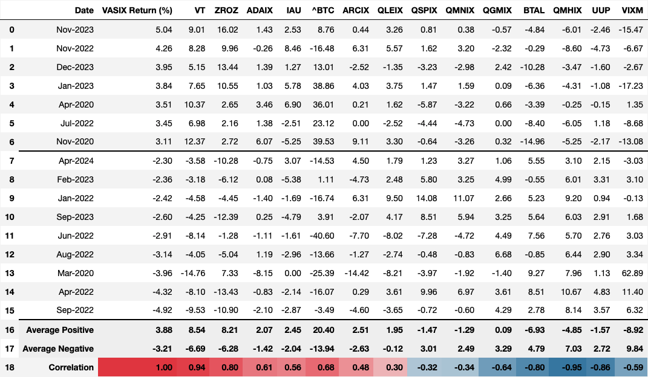

*Table 3 - Asset Returns During Benchmark Outlier Months*

***Annualized Asset Risk-Return Characteristics***

From here forward, we will switch to annualizing returns because that is easier for investors to relate to. Table 4 starts by displaying the compound annual growth rate (CAGR) of each asset. CAGR represents a geometric mean, as opposed to the arithmetic means we have been discussing so far. It is computed with the following formula:

$CAGR={\left(\prod{}\left(1+r_{i}\right)\right)}^{\frac{1}{T }}-1$

Where:

* $r_{i}$ is each monthly return.
* $T$ is the total number of years.

Notably, while VASIX’s mean monthly return only exceeded one asset, its CAGR is higher than six other assets due to a lower drag from volatility discussed above.

We also show the annualized standard deviation for each asset, which is given by the following formula:

$σ_{annual}= σ_{monthly}× \sqrt{12}$

Where:

$σ_{annual} is the annualized standard deviation \left(volatility\right).$

$σ_{monthly} is the standard deviation of monthly returns.$

* The factor $\sqrt{12}$ accounts for the fact that there are 12 months in a year.

The table of annualized risk and return characteristics helps contextualize what standard deviation really means for an investor. While most of the CAGRs seem moderately positive, the swings in the best years versus the worst years and maximum drawdowns can be wild (even ignoring the extremes from BTC). Ten of the 14 assets have standard deviations that are twice that of VASIX. Ten have maximum drawdowns of -25% or worse (many substantially worse). This demonstrates that investing is risky business and provides important context for what we demonstrate later when combining these assets into cohesive portfolios.

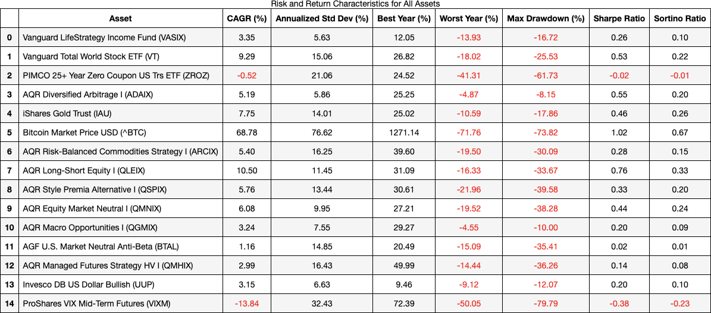

*Table 4 - Asset Risk-Return Characteristics*

***Asset Regressions Against the Benchmark***

To better understand the relationship between VASIX and the other assets, we performed an Ordinary Least Squares regression of the monthly returns of VASIX (the explanatory variable) against each asset (the response variable). Table 5 shows these results. Here, the intercept represents the annualized unexplained (arithmetic) return of an asset that is independent of the stock-bond drivers within VASIX. Beta is the coefficient that represents the sensitivity and asset has to VASIX. On this basis, VT and ZROZ have annual returns of 2.67% and-6.36%, respectively, neither of which is statistically significant at a 5% confidence level. They each have a highly statistically significant beta, consistent with the idea that they are highly related to VASIX. Eleven of the 12 other assets have positive intercepts, the lowest benign 3.83% of unexplained returns (ADAIX) that are still significant (p-value 0.0310). Five of the other 12 assets have statistically significant betas to VASIX, while six have statistically significant negative betas, which further corroborates the findings from the correlation matrix. Overall, the regression model indicates that most of the assets have independent sources of return that are economically large, if not all statistically significant. This is more promising evidence that combining them will prove fruitful.

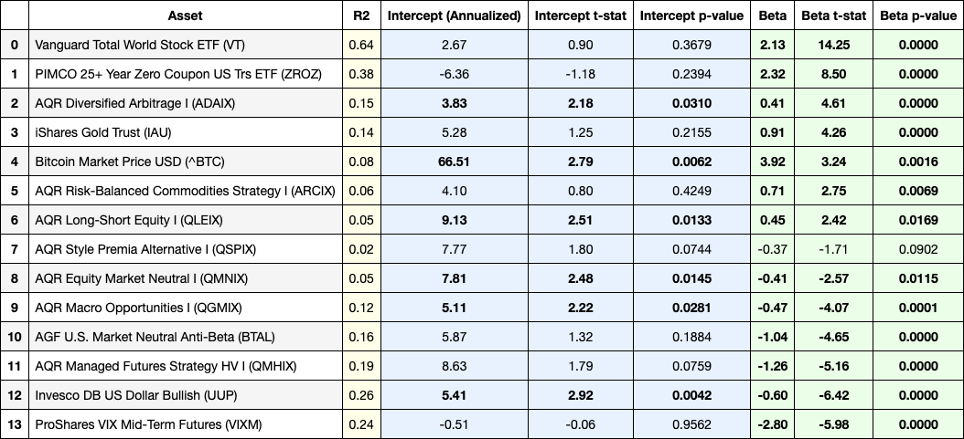

*Table 5 - Asset Regressions Against the Benchmark (VASIX)*

***Non-Parametric Bootstraps***

Table 6 shows the non-parametric bootstrap results for annualized returns and standard deviations, providing further insights into each asset's return distribution characteristics, reinforcing earlier conclusions. Across most assets, the bootstrapped confidence intervals reveal substantial return uncertainty and highlight the importance of considering the risk associated with tail events.

Although only one asset in our 118 month sample had a negative mean return (VIXM), the 95% confidence interval indicates that it is plausible for most of the assets to experience a negative average return over an approximately 10-year period.

On the right side of Table 6, we show the CAGR of each asset as well as an estimated CAGR resulting from the bootstrap process. This indicates that the bootstrap generates realistic mean estimates, but one should be cognizant of the width of the distribution and the possibility that left-tail outcomes could result in negative CAGR for prolonged periods of time. We will explore this possibility later with Monte Carlo simulations.

The formula for estimating compound annual returns (also known as geometric returns) given the arithmetic mean (µ) and the standard deviation (σ) of annual returns is derived using the following approximation:

Estimated CAGR $≈ μ- \frac{1}{2}σ^{2}$

Where:

* $μ$ is the annualized arithmetic mean of the returns.
* $σ$ is the annualized standard deviation of the returns.

This approximation accounts for the volatility drag, which occurs because returns compound over time. The higher the volatility (σ), the more it reduces the compounded return compared to the arithmetic average return.

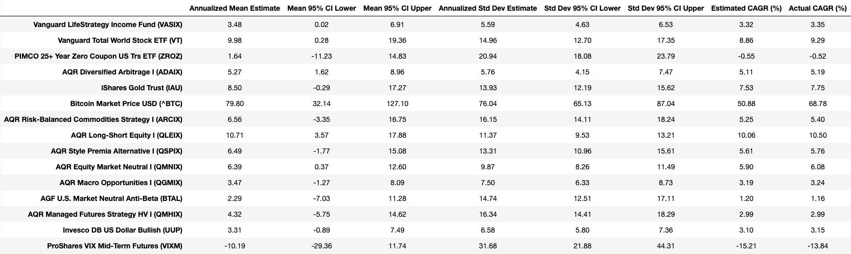

*Table 6 - Non-Parametric Bootstrap Results (10,000 Iterations)*

***Rolling 36-Month Annualized Means, Standard Deviations, and Risk-Adjusted Returns***

The rolling 36-month means, standard deviations, and risk-adjusted returns in Figure 7 offer perspective on risk and return variability over time. There are two main takeaways:

* First, every asset experienced significant fluctuations in performance over 3-year periods; many, in fact, had negative returns at some point during the sample period. VASIX had a reasonably stable return for more than half of the time frame, but it fell negative over the latter portion. However, over half of the assets saw some of their strongest 36-month performance when VASIX was at its lows. This highlights how certain assets can excel when others underperform over multi-year periods (as opposed to merely a monthly basis), suggesting that reasonable returns may be preserved when traditional core portfolio components (stocks and bonds) are generating lower risk adjusted returns.
* Second, standard deviation also varied over time, but to a much lesser extent than mean returns; this is important because variances combine with correlations to produce a diversification benefit in the form of a lower portfolio standard deviation. We already saw that rolling cross-correlations were low throughout the sample period (Figure 4 above). Therefore, relatively stable variances indicate that diversification may be reasonably stable, as well.

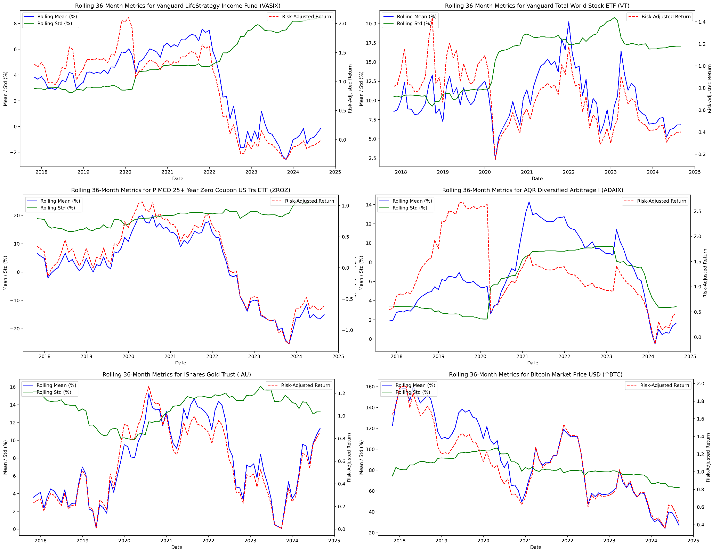

*Figure 7 - Rolling 36-Month Means, Standard Deviations, and Risk-Adjusted Returns*

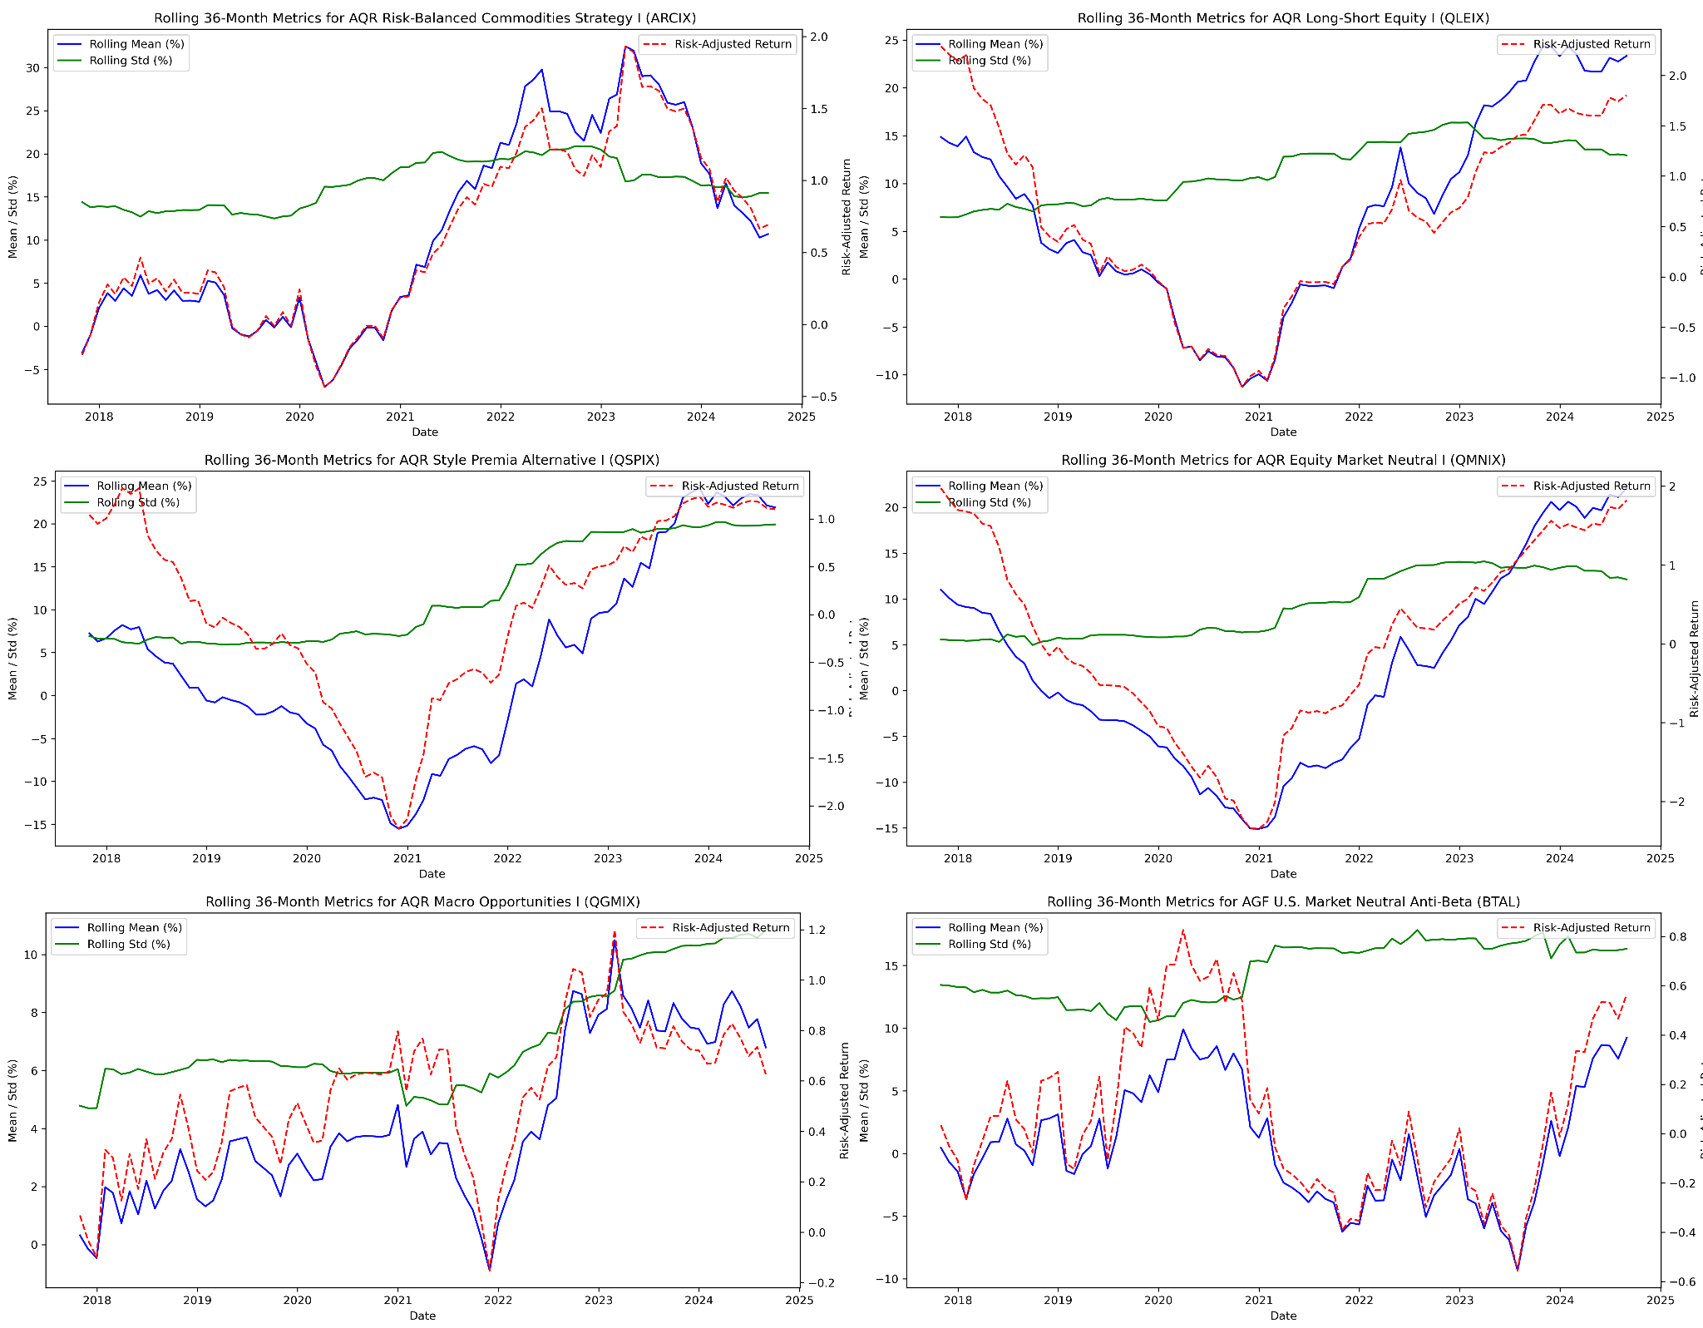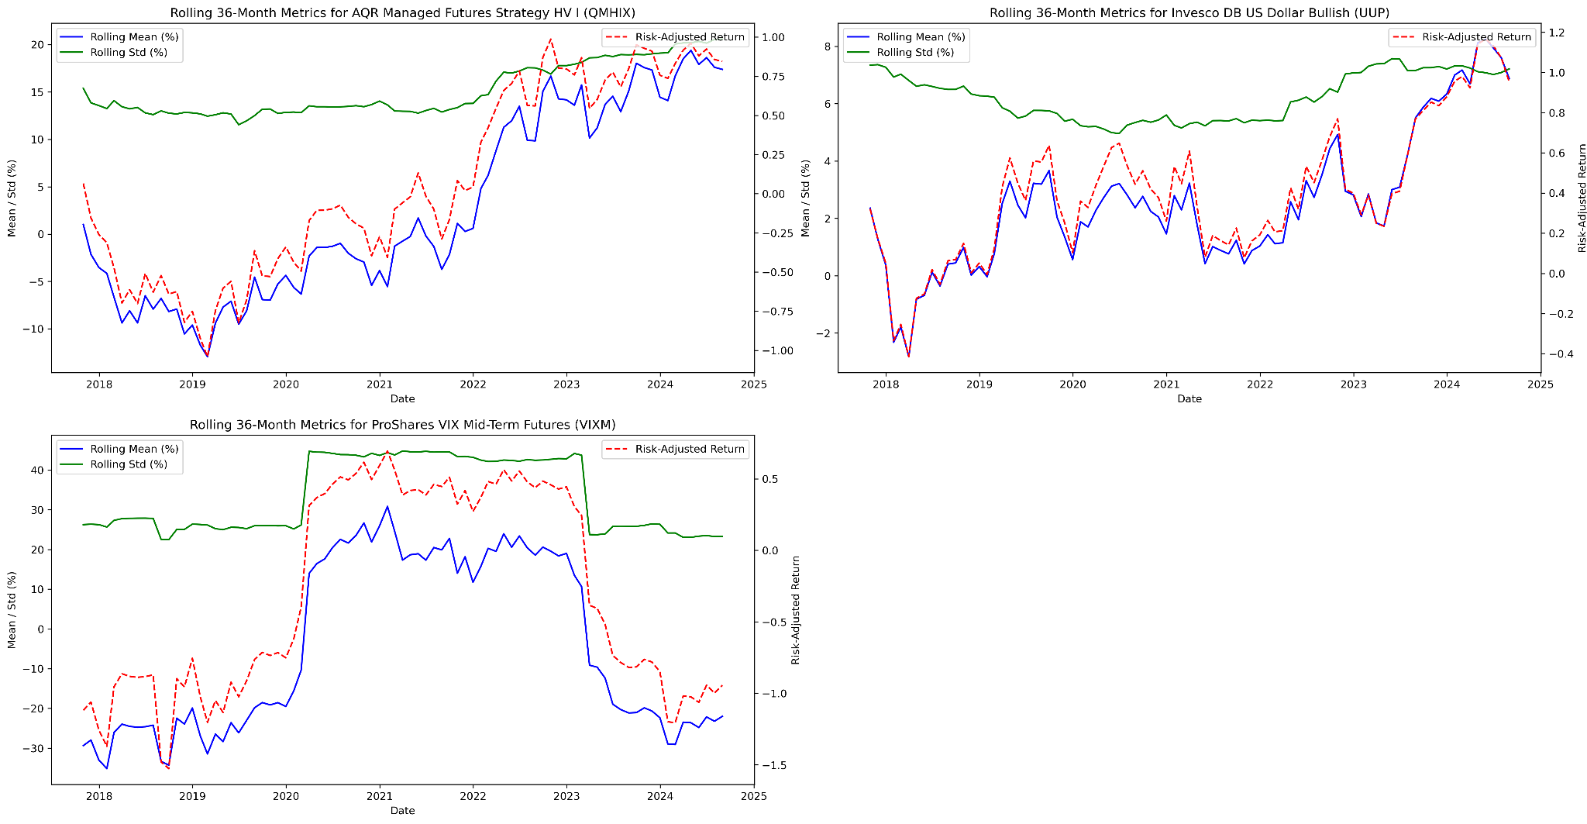

*Figure 7 - Rolling 36-Month Means, Standard Deviations, and Risk-Adjusted Returns, Cont.*

***Raw Return Histograms with Fitted Probability Distributions***

Histograms of monthly returns with fitted T, Cauchy, and normal distributions, shown in Figure 8, provide essential insights into the underlying characteristics of the asset in the opportunity set. Generally, most assets demonstrate significant deviations from normality, with higher peaks, heavier tails, and skew, suggesting that using a normal distribution to model these returns may underestimate the frequency and magnitude of extreme returns.

In summary, this analysis underscores the importance of selecting an appropriate probability distribution to model asset returns accurately. The T distribution often strikes a balance between capturing heavy tails without overestimating risk, making it a suitable candidate for modeling the returns of most assets in this study. These insights will be instrumental in informing our monte carlo analysis, ensuring that we account for non-normal return characteristics and accurately capture tail risks in our investment strategies.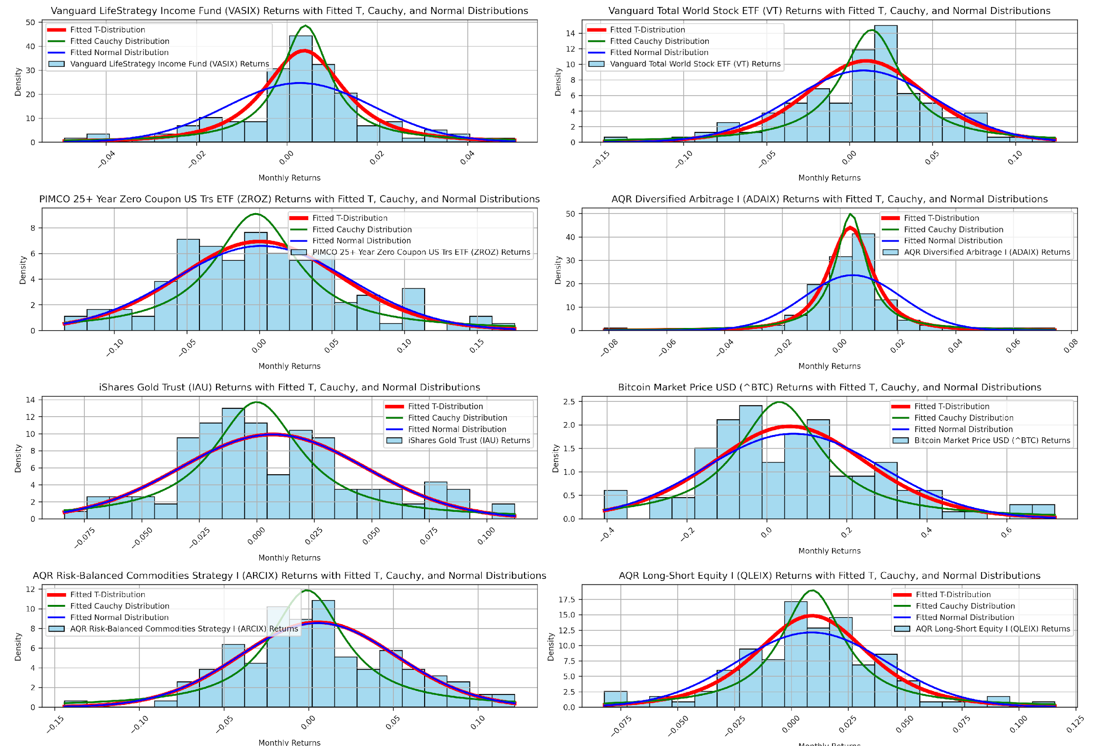

*Figure 8 - Raw Return Histograms with Fitted Probability Distributions*

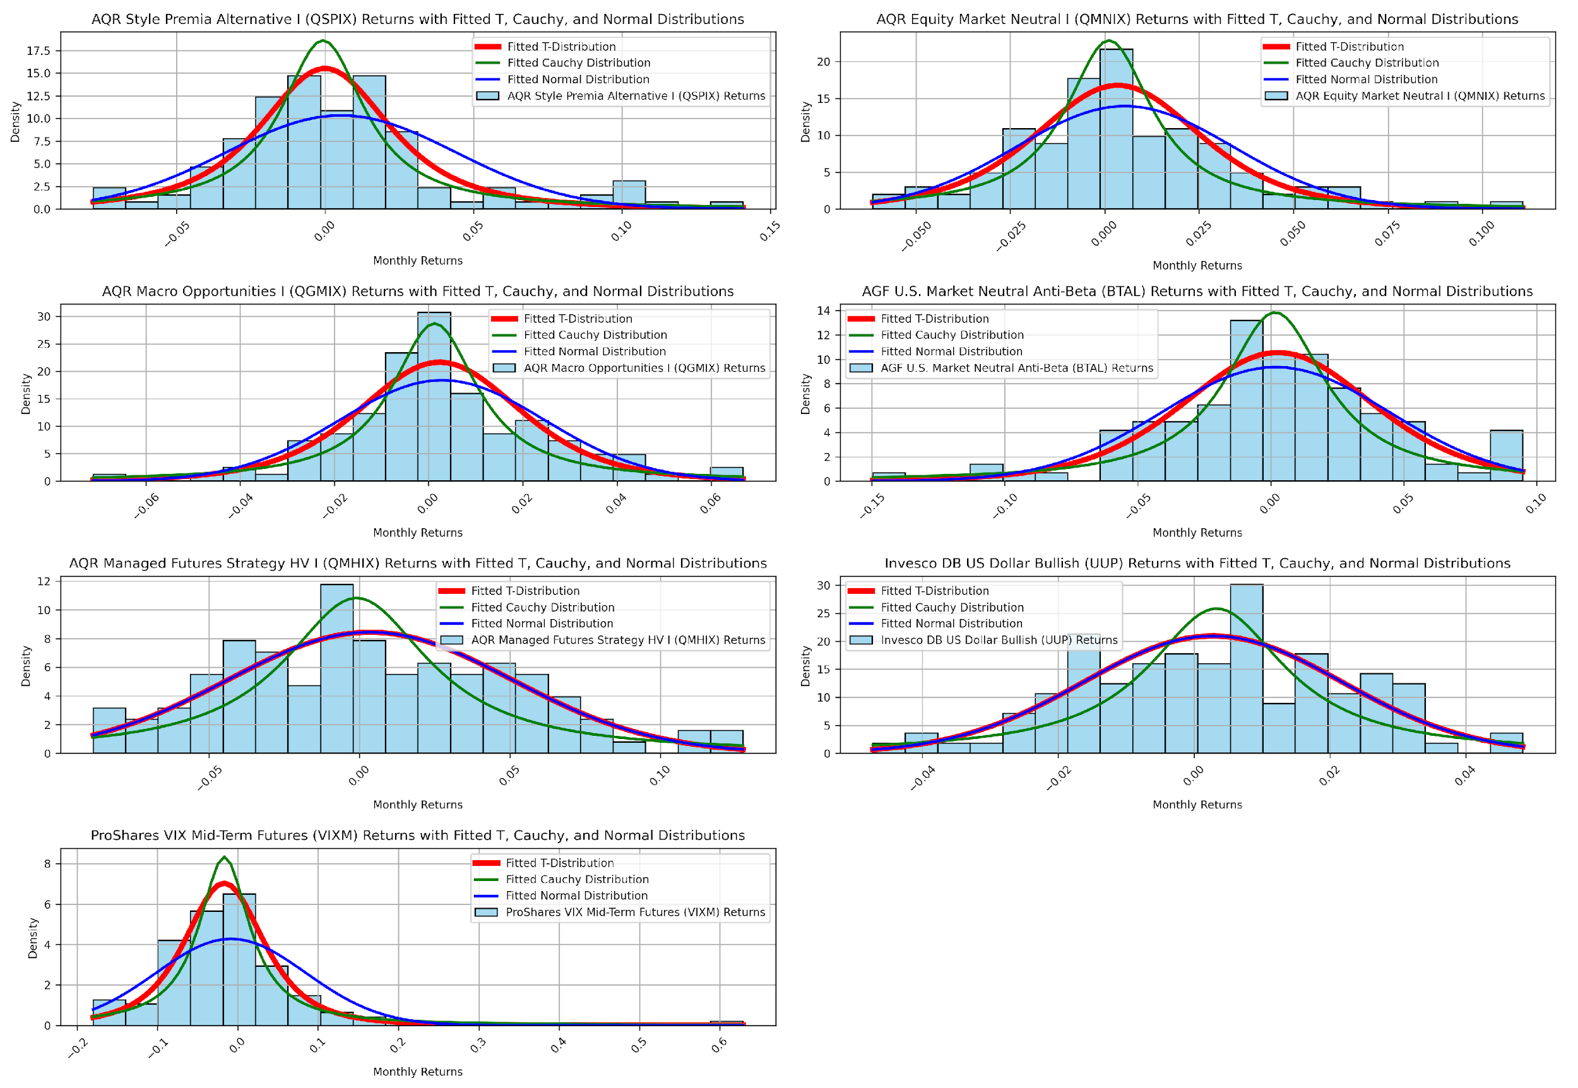

*Figure 8 - Raw Return Histograms with Fitted Probability Distributions (cont.)*

***QQ-Plots***

The QQ plots, shown in Figure 9, provide an additional validation layer for the histogram findings and fitted distributions. Across the different assets, the QQ plots consistently show that many distributions exhibit heavier tails than expected under a normal distribution, with deviations becoming especially pronounced at the extremes. This supports the earlier conclusion that a normal distribution is often insufficient for modeling financial returns, as it underestimates the likelihood of extreme events.

Overall, the QQ plots confirm that the return distributions for most assets are non-normal, with heavier tails and occasional skewness. This further highlights the importance of choosing an appropriate probability distribution—such as the T-distribution—to accurately model these asset’s risk and return characteristics.

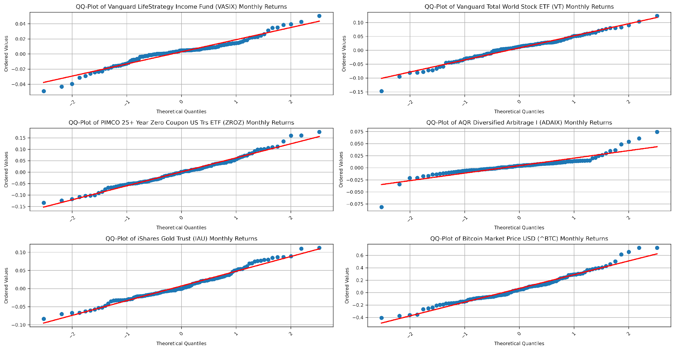



**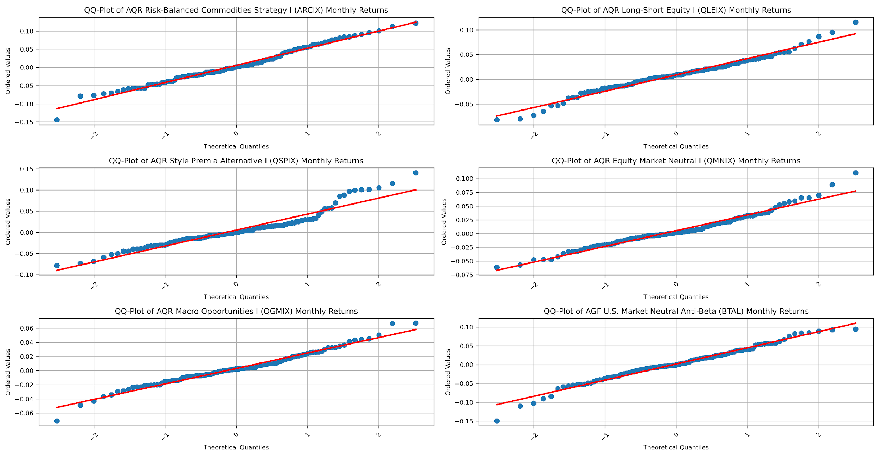****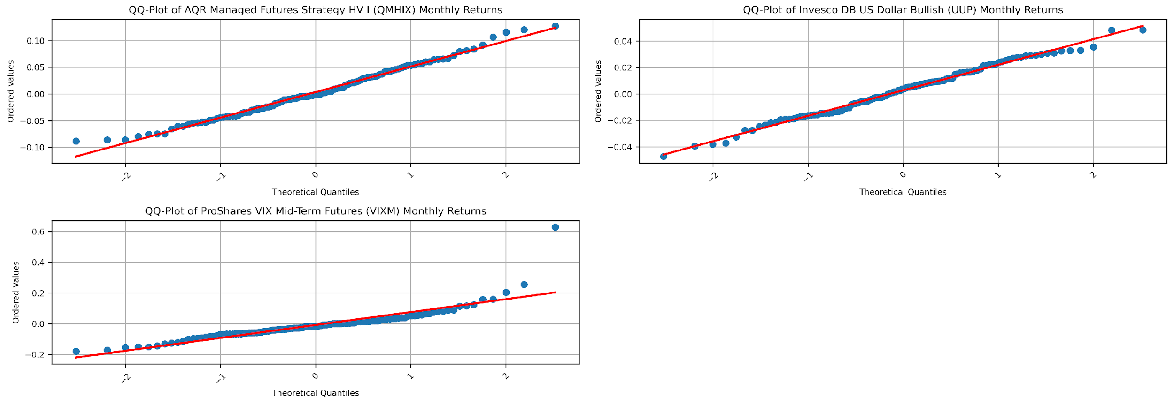**

*Figure 9 - QQ Plots (cont.)*

***Quantitative Goodness of Fit Tests: AIC, BIC, K-S***

The quantitative analysis using AIC (Akaike Information Criterion), BIC (Bayesian Information Criterion), and K-S (Kolmogorov-Smirnov) tests, shown in Table 7, supports the visual interpretations derived from histograms, fitted distributions, and QQ-plots, as well as our earlier observations of skew and kurtosis. Across most assets, the T-distribution consistently emerges as the best fit according to AIC and BIC, indicating that it captures the key characteristics of the return distributions, particularly the presence of heavy tails. This is also corroborated by the K-S statistic, which generally shows the lowest values for the T distribution, indicating a better overall fit. Although we know that the assets are not normally distributed, the Cauchy distribution tends to overestimate tail risks and peakedness.

This quantitative analysis affirms that the T-distribution is often the most suitable choice for modeling the return distributions of the diverse asset set under consideration. It captures the tail behavior more accurately than the normal distribution without the extreme risk overestimation that characterizes the Cauchy distribution.

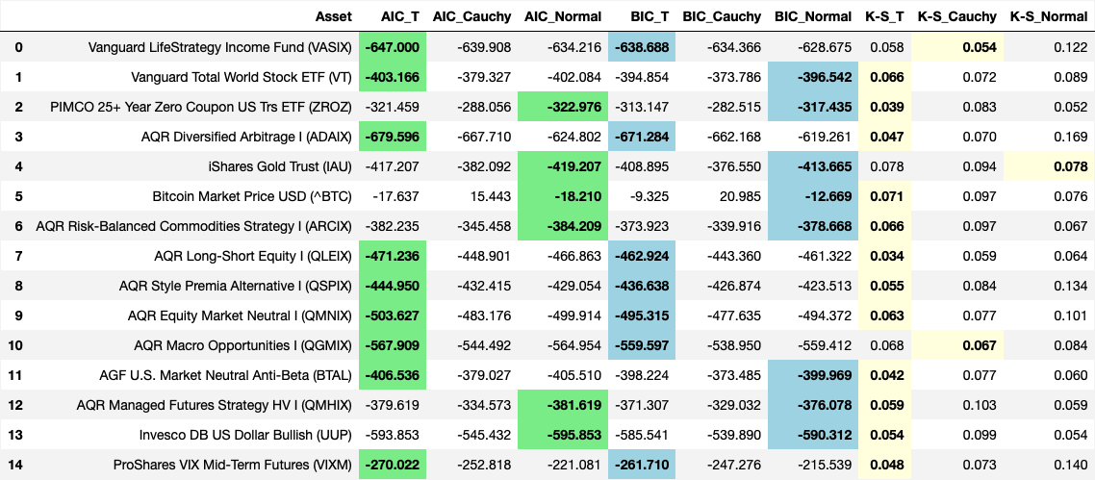

*Table 7 - Quantitative Goodness of Fit Tests (AIC, BIC, K-S)*

***Monte Carlo Simulations***

We conclude our exploratory data analysis with monte carlo simulations that consider 50th percentile (Table 8), 10th percentile (Table 9), and 90th percentile (Table 10) paths for each asset over a 36-month time period that is more relevant to a risk-averse investor than a 10-year horizon. We run 10,000 simulations using a T-distribution to better capture the extremity of the tails than if we had chosen to use a Normal distribution.

Important takeaways from this exercise are that 50th percentile outcomes still come with severe drawdowns within the 36-month period for any given asset. Every asset can experience a negative CAGR over 3-years. Even the conservative benchmark asset, VASIX, can produce a loss over a 3-year period in a 10th percentile episode–this very outcome was observed in our sample as shown in the rolling 36-month plot in Figure 6 above. Ultra-volatile assets like BTC have a real risk of a total wipeout–this does not mean it cannot be a component of a diversified portfolio, but that its statistical history comes with a starker warning than perhaps many commentators and enthusiasts understand. Finally, due to their volatility, even assets that have negative expected CAGR in a 3-year period (ZROZ, VIXM) can still have an expectation of strong performance when the right tail kicks in like in a 90th percentile outcome; this may be a welcome outcome if other uncorrelated assets are simultaneously experiencing a 10th percentile result. We will repeat this monte carlo simulation for the optimized portfolios later in this report, so the results for the individual assets can serve as helpful context when evaluating the benefit of diversification.

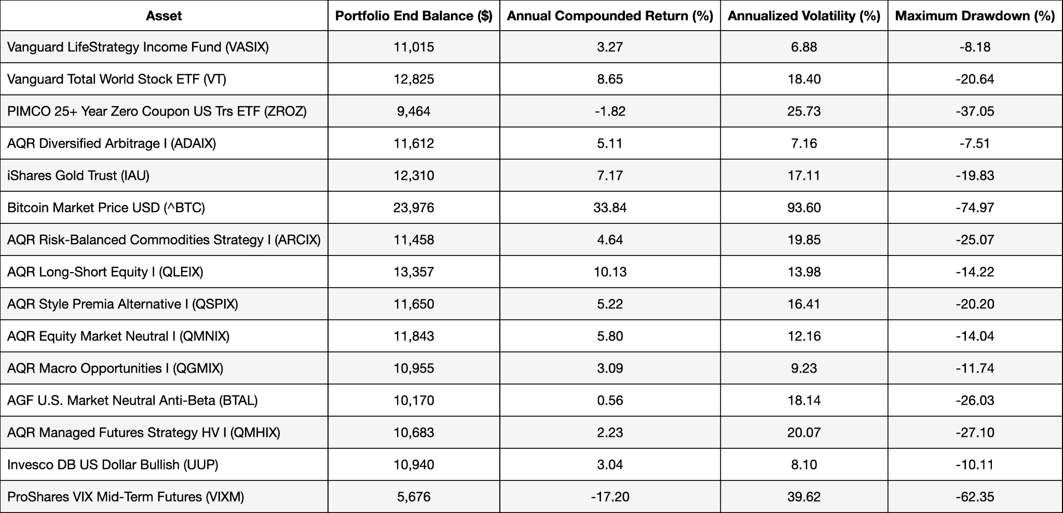

*Table 8 - 50th Percentile Monte Carlo Simulations Based on T-Distributions (36-Mo, 10,000 iterations)*

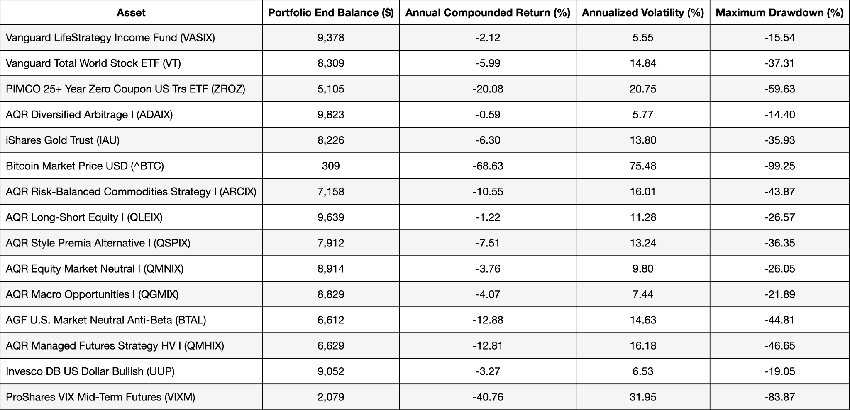

*Table 9 - 10th Monte Carlo Simulations Based on T-Distributions (10,000 iterations)*

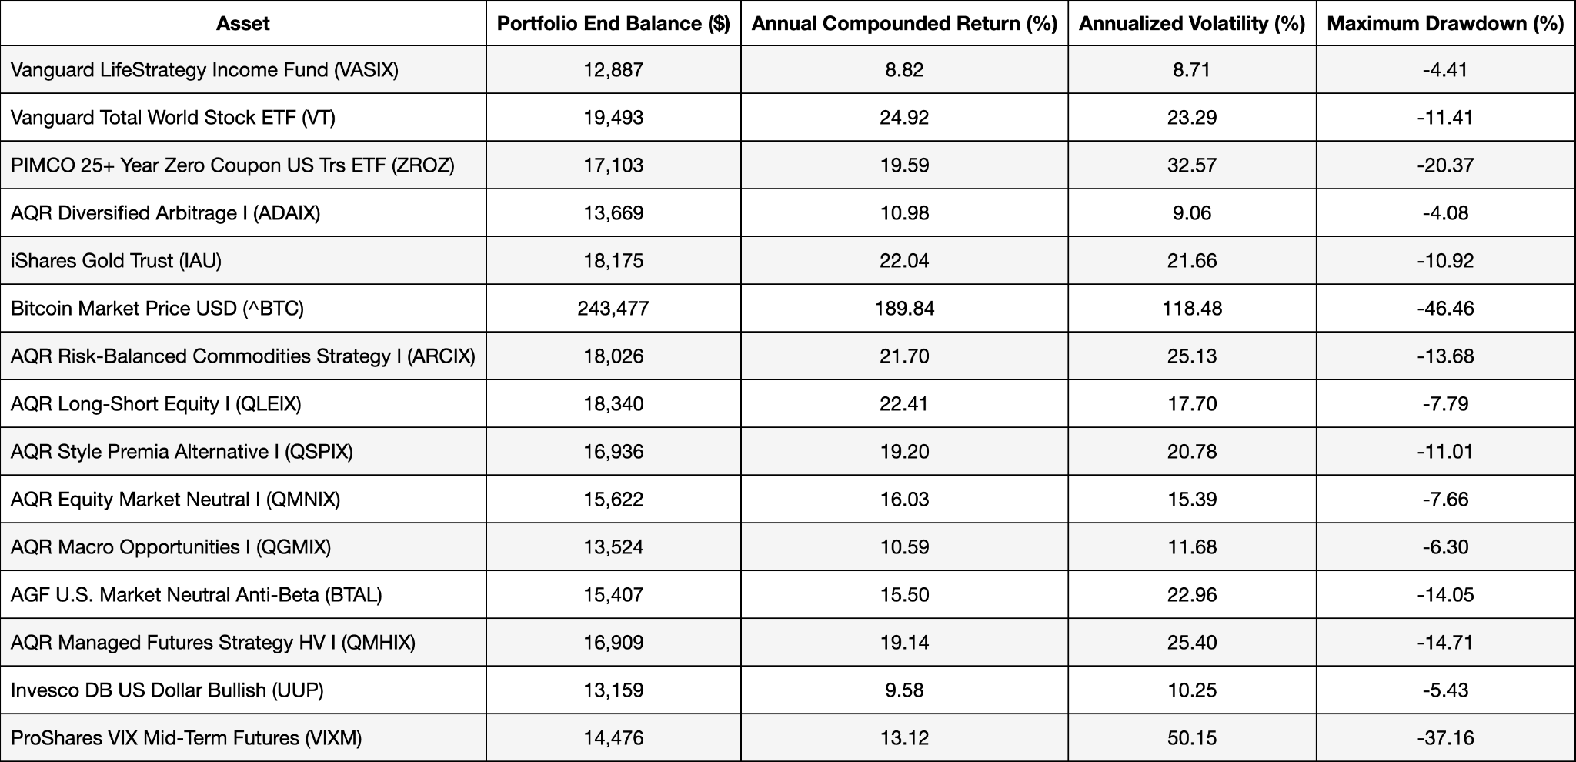

*Table 10 - 90th Monte Carlo Simulations Based on T-Distributions (10,000 iterations)*

**Model Selection**

*Risk Parity, Maximum Diversification, and Minimum Variance: An Analytic Perspective* by Clarke, de Silva, and Thorley (2013) discusses three portfolio optimization methods that use covariance matrices to construct portfolios which balance risk across assets without explicitly considering expected returns. We describe these three models in this section and test them in the next section.

Before presenting each method, it is worth noting two things about them:

* All the methods assume that the covariance matrix contains all the necessary information to describe the risk of the assets. Implicitly, this assumes that the returns are normally distributed and that relationships between assets are linear. We have already established that the probability distributions are non-normal. This suggests that more sophisticated methods of optimization may better account for these properties. Nevertheless, we believe this exercise is worthwhile to at least establish a baseline of performance and to see if violations of these assumptions appear to manifest in breakdowns of the portfolios as we noted with VASIX.
* Furthermore, these risk-based optimizations do not make assumptions about mean returns. There are two fair perspectives about this. One is that mean returns have such a wide confidence interval that is not worth weighting assets based on them. The other is that an investor should have an informed estimate of mean returns and should incorporate these forecasts into an optimization. We will see later if excluding means from consideration has an obviously detrimental impact.

***Risk Parity Optimization***

The principle behind risk parity is to weight assets in a portfolio so that each one contributes equally to the overall portfolio risk as measured by standard deviation. In mathematical terms, asset weights are inversely proportional to their volatility and adjusted for correlations between assets. Assuming no assets in the investable set have exceptionally low volatility, this approach avoids high concentrations in any one asset and spreads risk evenly across the portfolio, including all assets in the investable set.

**Objective Function**: The goal of Risk Parity is to equalize the risk contributions of each asset to the total portfolio risk. The total portfolio risk is defined as:

$$σ_{P}^{2}= \sum_{i}{}\sum_{j}{}w_{i}w_{j}σ_{ij}$$

Where:

* *wi*and *wj* are the weights of assets *i* and *j.*
* *σij* represents the covariance betweenassets *i* and *j.*

This formula calculates the portfolio's total variance, taking into account the weighted covariances between all pairs of assets in the portfolio. The portfolio is in risk parity when each asset’s risk contribution is the same. This means that:

$$w_{i} × Marginal Risk Contribution = \frac{σp}{N}$$

Where:

* *N* is the total number of assets.

Optimization constraints: Risk Parity portfolios are long-only, meaning weights are non-negative (i.e., *wi* ≥ 0 for all *і* ), and the sum of the weights must equal 1.

$$\sum_{i}{}w_{i} = 1$$

This constraint ensures that the portfolio uses the full capital allocation without shorting any assets.

***Maximum Diversification Optimization***

Maximum diversification aims to maximize the diversification ratio, which measures how much diversification is gained by comparing the weighted sum of individual asset volatilities (standard deviations)–for the assets that are given a positive weight–to the overall portfolio volatility. A higher ratio implies better diversification.

Objective Function: The objective of Maximum Diversification is to maximize the diversification ratio, which is defined as:

$$D_{p} = \frac{\sum_{i}{}w_{i}σ_{i}}{σ_{p}}$$

Where:

* $w$ is the vector of portfolio weights
* σ*i* is the volatility of the asset i
* σp is the portfolio's total volatility

This ratio measures how diversified the portfolio is relative to the weighted average

volatilities of its constituent assets.

Optimization constraints: Our Maximum Diversification optimizations are constrained to be long-only, meaning weights are non-negative (i.e., *w****i*** ≥ 0 for all *і* ), and the sum of the weights must equal 1.

$$\sum_{i}{}w_{i} = 1$$

This constraint ensures that the portfolio uses the full capital allocation without shorting any assets.

***Minimum Variance Optimization***

The minimum variance portfolio seeks to minimize the portfolio's standard deviation without considering expected returns. The optimization process aims to combine assets such that the resulting weighted variance is as small as possible. Assets with lower variance (less risk) tend to receive higher weights, though this is mediated by correlations with other assets. The portfolio can become relatively concentrated, often including a smaller subset of the investable assets compared to risk parity.

Objective Function: The Minimum Variance method minimizes expected portfolio variance without considering expected returns. The objective function is:

$$Minimize σ^{2}p = w^{⊤}\sum{}w$$

* $w^{⊤}$: Vector of asset weights in the portfolio.
* : Asset covariance matrix.

The objective here is purely to reduce the overall risk of the portfolio, making the minimum variance portfolio the leftmost point on the efficient frontier, representing the lowest possible risk (defined as standard deviation, the square root of variance) for a given set of assets.

Optimization constraints: Our Minimum Variance portfolios are constrained to be long-only, meaning weights are non-negative (i.e., *w****i*** ≥ 0 for all *і* ), and the sum of the weights must equal 1.

$$\sum_{i}{}w_{i} = 1$$

This constraint ensures that the portfolio uses the full capital allocation without shorting any assets.

**Model Analysis**

Having run the optimizations described above on our dataset, we now examine the findings. Remember that VASIX is the benchmark asset and is not included in the investable set of the optimizations.

***Portfolio Weights***

Table 11 shows the weight of each asset in each of the optimized portfolios. All three portfolios allocate at least 20% to one asset (for reference, if the portfolios were equally weighted, each asset would have roughly a 7% weight). Risk Parity retains and invests in all the assets, whereas Minimum Variance and Maximum Diversification each exclude four assets (three of which are in common). Risk Parity and Maximum Diversification both allocate some to BTC, but less than 1% in both cases due to its high volatility.

**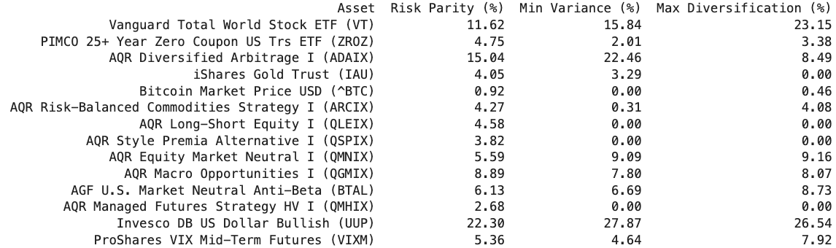***Table 11 - Optimized Portfolio Portfolio Weights Table*

***Risk Contribution***

Table 12 shows how Risk Parity achieves an equal contribution of risk for all 14 assets (approximately 7.1% each). By contrast, due to some higher allocations to certain assets and exclusion of other assets altogether, Minimum Variance and Maximum Diversification have rather wide-ranging risk contributions across their holdings, with some assets contributing 20%+ and others contributing less than 5%.

**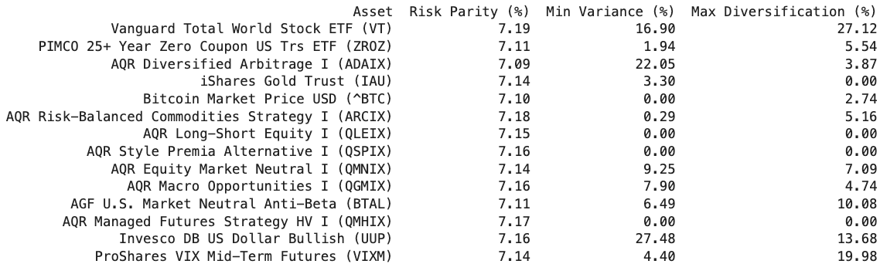***Table 12 - Optimized Portfolio Risk Contribution Table*

***Annual Returns***

Table 13 displays the annual returns of each portfolio as well as the benchmark asset, VASIX. Perhaps the biggest observation is the 2022 return, when VASIX lost almost 14%. In 2022, all three optimized portfolios generated low-to-mid positive single digit returns. This is consistent with our earlier findings of stable cross-correlations of the assets, relatively stable variances, and preserving their correlations when VASIX was experiencing negative outlier months.

Some other observations are that none of the optimized portfolios ever returned 10% or more in any one year, while VASIX did once. However, VASIX experienced calendar year losses twice, whereas Risk Parity only did once (with a slight -0.34% return in 2018), Minimum Variance did once (-0.03% in 2018), while Maximum Diversification never had a calendar year loss.

**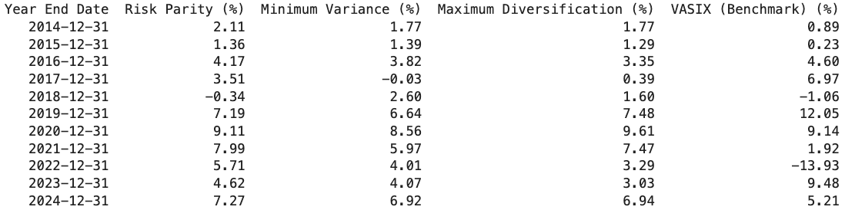***Table 13 - Optimized Portfolio Annual Return Table Versus Benchmark*

***Performance Summary***

Table 14 shows that all three optimizations generated a CAGR above VASIX (the slightly higher return from Risk Parity relative to the other two optimizations is due to its larger allocation to BTC). However, this superior growth rate did not come with elevated risks. In fact, the standard deviation of all three optimized portfolios was less than 3% per year whereas VASIX had more than a 5.5% standard deviation–this was apparent from the narrow distributions of calendar year returns in Table 12 for the optimizations versus VASIX. Lastly, none of the portfolios experienced a maximum drawdown below -3% whereas VASIX saw nearly a 17% drawdown.

**

*Table 14 - Optimized Portfolio Performance Summary Table Versus Benchmark*

***Optimized Portfolio Rolling Performance***

Earlier, we saw that individual assets had big swings in their rolling 36-month mean return. In Figure 10, we observe that while VASIX experienced a large drop off in its rolling 36-month return, which was attended by a near doubling in its rolling 36-month standard deviation, the optimized portfolios did not experience these same deleterious effects.

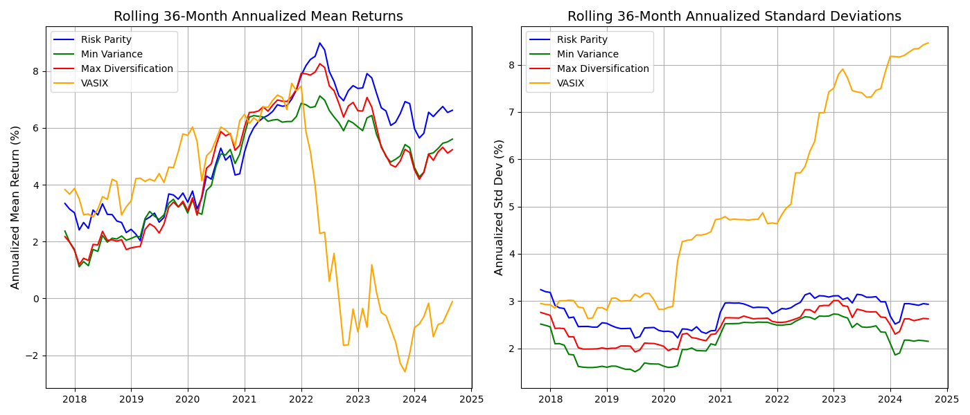

*Figure 10 - Optimized Portfolio Rolling 36-month Mean and Standard Deviations*

***Regression Analysis***

Table 15 shows the results of the same method of regression that was performed on the individual assets. All three portfolios have a small positive beta to VASIX due to the inclusion of VT and ZROZ in them. However, the bigger takeaway is that they have an intercept that is 90% plus of their arithmetic return, meaning that nearly all of their return was from sources other than the exposures within the benchmark (intercepts are also arithmetic, so we can do an apples to apples comparison). Correspondingly, they all have coefficients of determination (R-squared) near zero, supporting the idea that the return drivers come from exposures that are diversified well beyond that of bonds and stocks.

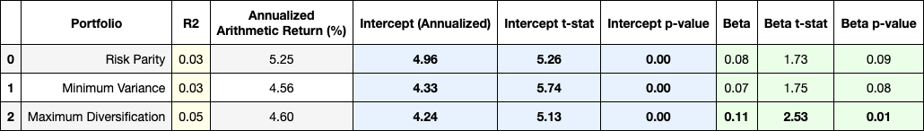

*Table 15 - Optimized Portfolio Performance Regression Against Benchmark*

***Optimized Portfolio Summary Statistics***

The mean, standard deviation and monthly average returns for the optimized portfolios in Table 16 are unsurprising, given the performance described so far. The main observation here is that the optimized portfolios had right-skew, whereas VASIX had negative skew. This indicates that negative outcomes were successfully truncated and that there was a higher frequency of high one-month returns. This is evident in the smaller magnitude of the minimum returns versus the maximum returns for the optimized portfolios.

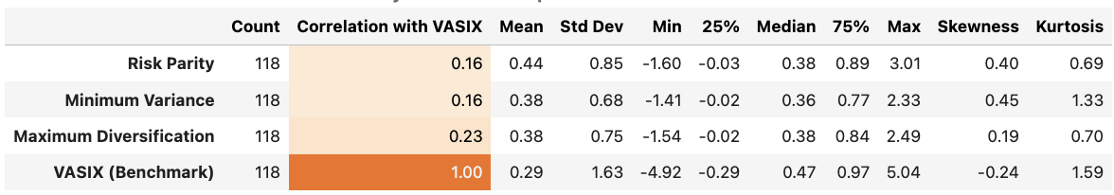

*Table 16 - Optimized Portfolio Summary Statistics*

***Optimized Portfolio Goodness-of-Fit***

The goodness-of-fit tests for the portfolios indicates that T-distributions continue to be the best probability distribution to describe them (Table 17).

*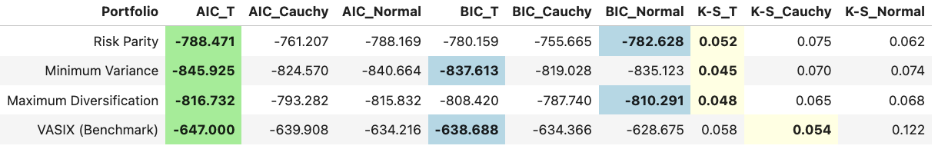Table 17 - Optimized Portfolio Quantitative Goodness of Fit Tests (AIC, BIC, K-S)*

***Optimized Portfolio Monte Carlo Analysis***

When we run the portfolios through the 36-month monte carlo simulations, modeled as T-distributions, we see that all three optimized portfolios had 10th percentile CAGR outcomes of 2%+ over 3-year periods, which is similar to the 3-year mean return seen in Figure 10 around the year 2018 (Table 18). This compares to a 10th percentile return for VASIX of -2%, which was observed in the 3-years ending just before 2024. The optimized portfolios did not quite experience 10th percentile drawdowns during the sample period, while VASIX did surpass its 10th percentile drawdown estimate slightly.

*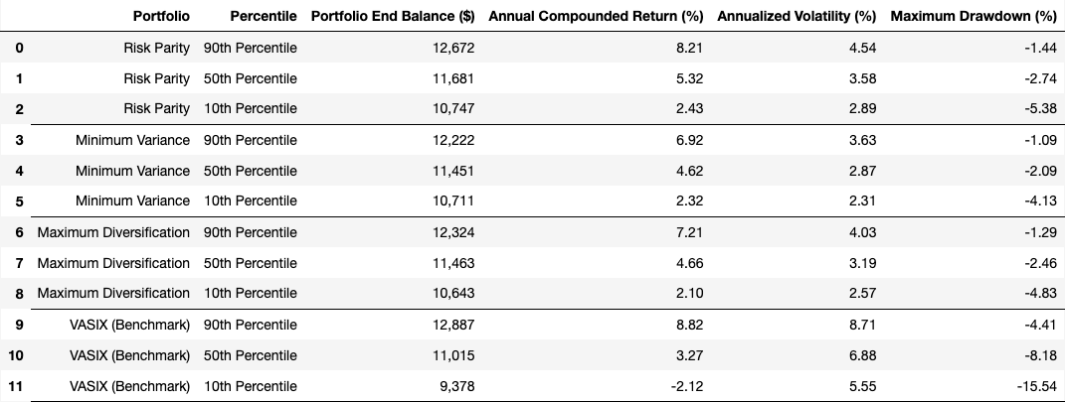Table 18 - Optimized Portfolio Monte Carlo Analysis (36-Months, 10,000 Iterations)*

***Ex-Ante vs Ex-Post Portfolios***

One critical aspect to discuss is that these portfolio results are ex-post, meaning that the optimized weights were determined based on the full sample of asset correlations and standard deviations which could not have been known with certainty in advance. We did this to first illustrate the concept with the largest time frame of results. However, to have confidence that these optimizations can be used effectively in an ex-ante context (meaning, setting weights based on past characteristics and then assessing the subsequent performance when the future correlations and standard deviations are unknown), we also conducted rolling optimizations based on prior 12-month correlations and variances. For example, the rolling portfolio weights assigned in November of 2015 were based on the prior 12-month covariance data from November, 2014 through October, 2015. Then the lookback rolls forward by a month such that the December, 2014 weights are based on the 12-months ending in November, 2014. This had the effect of shortening the evaluation period to 106 months (just under nine years).

For brevity, we are only displaying the annual returns and performance summary table (Table 19), but the results of the other exhibits are consistent with these ex-ante findings, which are that all three optimized portfolios show slightly better performance in every respect (CAGR, standard deviation, drawdowns, and worst calendar years).

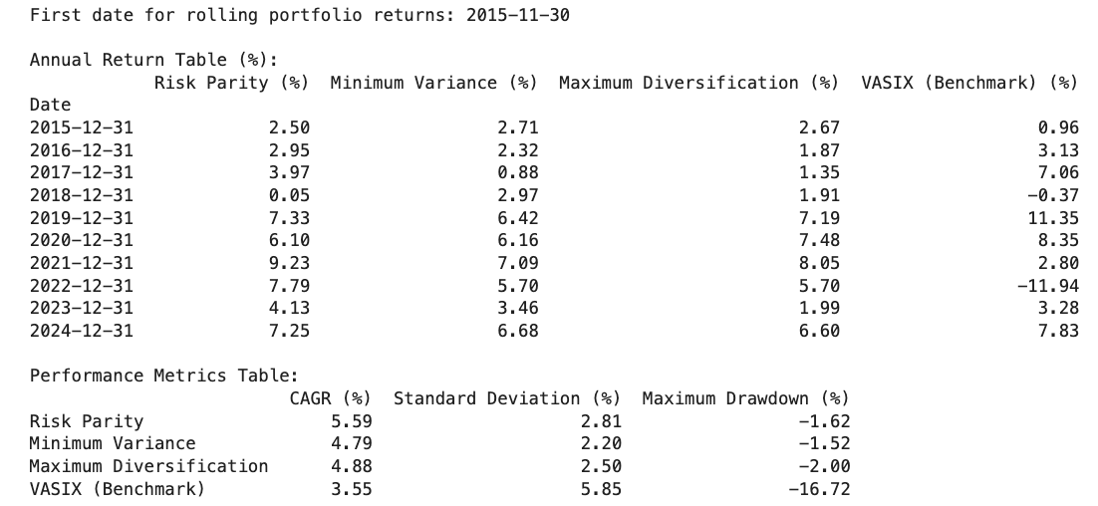

*Table 19 - Rolling Optimized Portfolio Annual Return*



*Table 20 - Performance Metrics Table*

**Conclusion and Recommendations**

Our analysis demonstrates that the diversification opportunities available within the asset set offer substantial potential for optimizing portfolios that meet clients' needs for consistent returns while mitigating risk. The Risk Parity approach, in particular, stands out due to its balanced risk distribution and ability to include a wide range of assets without over-concentration. Based on our findings, we propose the following recommendations and next steps to further refine and enhance portfolio strategies:

1. **Extend Data Collection**: Our analysis used a common time frame during which all assets were publicly available as mutual funds or ETFs. While this period included a variety of macroeconomic conditions, it does not capture the full range of market cycles. Expanding the dataset to include additional periods and a broader range of macroeconomic conditions could improve the model's robustness. This can be achieved through:
   * Including funds with longer historical records.
   * Using similar funds or proxies for periods before specific assets were available.
   * Incorporating published indexes that represent these products or their proxies.
   * Creating regression-based approximations using risk factor and macroeconomic data.
   * Simulating price histories to preserve variance and correlations across assets.
2. **Increase Sample Size**: Expanding the dataset would effectively increase the sample size, which could provide more reliable insights into the stability of covariance structures and other statistical properties.
3. **Leverage Machine Learning for Asset Clustering**: Employ machine learning techniques to cluster assets based on their unique risk-return characteristics. Clustering could simplify portfolio construction by reducing redundancy and offering a representative set of assets that capture distinct risk factors, particularly for the Risk Parity approach.
4. **Broaden Goodness-of-Fit Testing**: Extend the goodness-of-fit analysis by incorporating additional tests, such as Anderson-Darling, Shapiro-Wilk, D'Agostino’s K-squared, and Jarque-Bera, to assess skewness and kurtosis more comprehensively. Additionally, consider alternative probability distributions to enhance the accuracy of the model.
5. **Improve Monte Carlo Simulations**: Conduct more precise Monte Carlo simulations over multiple time periods, using parametric simulations informed by enhanced goodness-of-fit findings. This will provide deeper insights into asset and portfolio performance under various stress-testing scenarios.
6. **Conduct Risk Factor Analysis**: Perform detailed regression analyses of assets against macroeconomic and financial market factors to isolate key performance drivers. This could also help in constructing synthetic returns for assets with limited historical data, filling gaps in time series data. Further, regression results can inform stress tests for hypothetical financial market scenarios, providing a broader view of potential risks.
7. **Evaluate Additional Assets**: Explore other investment products that may provide exposure to uncorrelated returns. Consider newer funds that may not have been included in this study due to the limited historical sample. Broader asset selection could further enhance diversification opportunities.
8. **Revisit Other Optimization Methods**: With additional data and deeper analysis, it may be worth reevaluating other portfolio optimization models, including non-linear methods not discussed in this study. These methods could offer superior performance in addressing non-normal return distributions.

Overall, this study demonstrates the efficacy of diversified portfolio construction strategies that extend beyond traditional stock-bond allocations using liquid investment products. While the Risk Parity approach offers a solid foundation for portfolio optimization, we recommend further exploration of the above strategies to enhance the robustness and understanding of portfolio management.

**References**

Agresti, A., & Kateri, M. (2022). Foundations of statistics for data scientists: With R and Python. *CRC Press, Taylor & Francis Group*.

OpenAI. (2024). ChatGPT (GPT-4o version) [Large language model]. https://chatgpt.com/

Clarke, R., de Silva, H., & Thorley, S. (2023). Risk parity, maximum diversification, and minimum variance: An analytic perspective. *Journal of Portfolio Management.*

SRL Global Ltd. (2024, September 16). Backtest portfolio asset allocation. *Portfolio Visualizer.* Retrieved September 16, 2024, from https://www.portfoliovisualizer.com/backtest-Portfolio?s=y&sl=5M8RhWX2CyedGtfIDJRlyP

**Appendix A**

**Projected Project Timeline/Deliverables**

|  |  |  |  |
| --- | --- | --- | --- |
| Week 3 | 9/16/2024 | Form Teams, Choose Project/Dataset | Ian/Carrie |
|  | 9/21/2024 | In-Person Meeting, Create Collab Files/Folder | Ian/Carrie |
|  | 9/22/2024 | Formulate Research Questions | Ian |
|  | 9/23/2024 | Generate Business Objective | Carrie |
|  | 9/23/2024 | Review Dataset, Generate Data Descriptives | Carrie |
| Week 4 | 9/24/2024 | Outline Data Analysis Plan | Ian |
|  | 9/28/2024 | Develop Preliminary Models | Ian/Carrie |
|  | 9/28/2024 | In-Person Meeting, Analyze Models | Ian/Carrie |
|  | 9/29/2024 | Develop Conclusions and Recommendations | Ian/Carrie |
|  | 9/30/2024 | Submit Final Project Check-in | Ian |
| Week 5 | 10/1/2024 | Draft Report | Ian |
|  | 10/1/2024 | Draft Presentation | Carrie |
|  | 10/5/2024 | In-Person Meeting, Review Drafts | Ian/Carrie |
| Week 6 | 10/8/2024 | Review Tables/Figures/Visualizations | Ian/Carrie |
|  | 10/8/2024 | Review References/Sources/Links | Ian/Carrie |
|  | 10/11/2024 | Finalize Final Report | Carrie |
|  | 10/12/2024 | In-Person Meeting Presentation Rehearse | Ian/Carrie |
|  | 10/12/2024 | Finalize Presentation | Ian |
|  | 10/12/2024 | Record Project Presentation | Ian/Carrie |
| Week 7 | 10/21/2024 | Submit Final Report /Presentation | Ian |

**Appendix B**

**Jupyter Notebook/Code**